1. Introduction
1.1 Project Overview
In today’s competitive manufacturing sector, especially within the toy industry, understanding production trends and state-wise dynamics is crucial for making strategic decisions. Manufacturers often rely on historical data to spot patterns, allocate resources, and respond to changing market demands — yet lack a visual, centralized tool for such analysis.
This project titled “US Toy Manufacturing Trend Analysis Using Tableau” focuses on uncovering insights from structured time-series data spanning over a decade (2005 to 2016), covering metrics such as number of manufacturers, toy production volume, and state-wise contributions across the United States.
By utilizing Tableau, we transform raw CSV data into dynamic dashboards that help stakeholders answer key questions:
Which states had the most active toy manufacturing industries over time?
How did the number of manufacturers evolve year by year?
Are there patterns or declines related to economic cycles or policy changes?
The project leverages visual storytelling and interactivity to help non-technical users — such as policymakers, industry analysts, and investors — explore national and regional manufacturing trends in an intuitive format. It provides a historical 360-degree view of the toy manufacturing industry in the U.S., facilitating evidence-based planning and growth strategies.

1.2 Purpose
The purpose of this project is to enable data-driven decisions in the manufacturing sector by visualizing and analyzing how variables such as state-wise participation, yearly trends, and manufacturing distribution impact overall industry insights.
Government agencies, toy companies, and supply chain analysts often struggle to interpret raw CSV datasets — especially when working with multi-year data across multiple states. This project addresses that challenge by creating an interactive Tableau dashboard that converts these historical records into clear, actionable insights.
Through this dashboard, stakeholders can:
Visually compare the number of manufacturers across different U.S. states.
Detect trends and shifts in manufacturing output over time.
Identify regions with consistently high or low manufacturing activity.
Support regional planning, policy creation, and industry investment.
This solution simplifies industry analysis by:
Offering custom filters like year selection and state comparison.
Highlighting visual trends through line charts, heatmaps, and bar graphs.
Presenting storytelling dashboards that summarize key insights effectively.
Ultimately, the purpose is to empower stakeholders in the U.S. toy manufacturing industry with a scalable, visual analytics platform that promotes better decision-making, supports industrial policy development, and enhances understanding of long-term trends.

2. IDEATION PHASE
2.1 Problem Statement
Industry experts and decision-makers in the toy manufacturing sector lack real-time visibility into how state-level participation and yearly production volumes evolve over time. Decisions around investment, policy support, or supply chain planning are often based on outdated reports or fragmented datasets.
Without a centralized visual tool, it becomes difficult to:
Understand which states are losing or gaining manufacturing momentum.
Compare production trends across different time periods.
Identify macroeconomic influences on manufacturing output.
Spreadsheets and traditional tools:
Lack interactivity and drill-down capabilities.
Do not support multi-variable analysis (e.g., state vs. year trends).
Require tedious manual effort to summarize 12 years of data.
This challenge is magnified when tracking national-level industry trends across 50 states over more than a decade. There is a strong need for:
An interactive dashboard that visualizes national and state-wise toy manufacturing trends.
A tool that helps detect long-term declines or spikes with ease.
A system to guide investment, planning, and policy decisions with clear data insights.
This project solves that problem by developing a Tableau dashboard that connects industry analysts and business users directly to a rich, visual, and historical dataset — enabling better analysis, faster conclusions, and stronger planning.
. 2.2 Empathy Map Canvas : 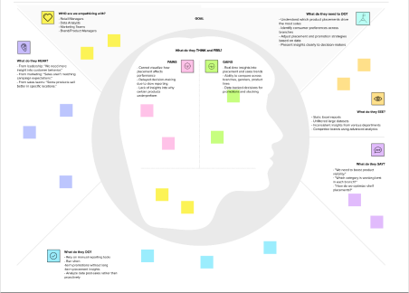

2.3 Brainstorming
2.3.1 Team Collaboration and Approach
To kick off the project, our team conducted a collaborative brainstorming session to explore various ways to analyze trends and performance within the U.S. toy manufacturing industry from 2005 to 2016. We examined the dataset titled "US Toy Manufacturers – 2005 to 2016", focusing on key variables such as:
State-wise Manufacturer Count
Yearly Trends (2005–2016)
Average Manufacturer Count by Year
Top Performing States
Total and Average Metrics
We discussed how these variables reflect economic shifts, regional industrial strengths, and market performance. Visualizations were proposed that could communicate these findings effectively to stakeholders such as policy planners, economic analysts, and business strategists.

2.3.2 Ideas Generated and Grouped by Category
Idea Category | Idea
Trend Analysis | Line chart showing number of manufacturers over time
Regional Comparison | Bar chart comparing states by number of manufacturers
Performance Highlighting | Heatmap for high vs low manufacturing states over time
Geographic Visualization | Map showing state-wise contribution to toy manufacturing
Interactivity | Add filters for year, state, and average threshold
User Engagement | Word cloud showing most frequently high-performing states
Economic Insight | Waterfall chart showing changes in national totals over years
Storytelling/Presentation | Tableau Story guiding users through key phases and findings

2.3.3 Prioritization
Priority | Idea | Reason
High | Line Chart for Manufacturer Count over Time | Core to understanding overall industry trend
High | Bar Chart by State | Essential for comparing regional performance
High | Heatmap by Year and State | Highlights trends and seasonality effectively
High | Filters by State, Year | Improves user interactivity and exploration
Medium | Map Visualization | Adds a geographic perspective
Medium | Waterfall Chart | Provides deeper economic interpretation
Low | Word Cloud of States | Enhances engagement but not critical to main insight
Low | Storyboard | Useful for presentation, not essential for analysis

3. REQUIREMENT ANALYSIS
3.1 Customer Journey Map
The Customer Journey Map illustrates the user experience from recognizing the problem (lack of visibility in manufacturing trends) to adopting the Tableau dashboard for strategic insights. Our primary users include industry analysts, policymakers, and manufacturing consultants.
Stage | User Action | User Experience | Pain Points / Barriers | Dashboard Solution
Awareness | Observes unclear national trends or state performance | Frustrated by lack of clarity | Too much raw data, difficult to track over time | Timeline chart of manufacturer count
Consideration | Analyzes Excel manually | Overwhelmed by static data | Excel lacks visuals, hard to spot patterns | Interactive filters by state and year
Adoption | Loads data into dashboard | Feels empowered with control | Unsure how to compare states effectively | Heatmaps, state-wise bars
Insight | Discovers long-term drop in manufacturers in some regions | Informed and alert to change | Can't validate assumptions without data context | Year-over-year comparison visuals
Action | Recommends focus on top states or invests in struggling areas | Confident in strategy and decisions | Lacks presentation tools | Story dashboard + export features
Feedback | Shares dashboard with leadership | Empowered and aligned as a team | Wants to customize visuals for deeper segmentation | Tableau Story + filters + export to PDF/PNG

3.2 Solution Requirement
Functional Requirements (FRs)
FR No. | Functional Requirement (Epic) | Sub-Requirement (Story / Sub-Task)
FR-1 | Upload Data | Upload US Toy Manufacturers – 2005 to 2016.csv dataset into Tableau
FR-2 | Data Preprocessing | Clean nulls, convert year to datetime, rename long headers
FR-3 | Visualize National Trend | Line chart showing manufacturers per year
FR-4 | Compare States | Bar chart comparing state-wise manufacturer count
FR-5 | Highlight Changes | Heatmap showing manufacturer count over time per state
FR-6 | Geographic View | U.S. map showing manufacturing strength
FR-7 | Visual Storytelling | Create Tableau Story for structured presentation
FR-8 | Add Filters | Filters for year, state, top/bottom performance
FR-9 | Export Options | Allow export to PDF and PNG for presentation and sharing

Non-Functional Requirements (NFRs)
NFR No. | Requirement | Description
NFR-1 | Usability | Dashboard should be intuitive for non-technical users like policy analysts
NFR-2 | Reliability | Charts and KPIs must reflect updated filters without error
NFR-3 | Performance | Dashboard should load within 5 seconds for 1000+ rows
NFR-4 | Availability | Dashboard must be available via Tableau Public or downloadable formats
NFR-5 | Scalability | Should support additional years or regional breakdowns in the future
NFR-6 | Security | Data remains local or shared securely; no personal data exists in dataset

3.3 Data Flow Diagram (DFD)
A Data Flow Diagram (DFD) shows how data moves through the system—from input to final output—across different components. This project processes a CSV dataset (US Toy Manufacturers – 2005 to 2016.csv) through Tableau to create an interactive dashboard that supports historical trend analysis and regional manufacturing insights.
Level 1 DFD – Detailed Process Flow
Process Component | Description
1. Data Input | User uploads US Toy Manufacturers – 2005 to 2016.csv into Tableau
2. Data Cleaning & Formatting | Data types (e.g., year as integer), missing value handling, column renaming
3. Calculated Fields | Fields like Total Manufacturers per Year, Year-over-Year Growth Rate
4. Visualization Engine | Tableau sheets built using line charts, bar graphs, heatmaps, and maps
5. Filters | Filters for Year, State, National Avg Threshold, and Top/Bottom States
6. Dashboard Assembly | All visual sheets integrated into a single interactive Tableau dashboard
7. Storytelling Mode | Tableau Story created to guide stakeholders through key patterns and shifts
8. Output | Users export results to PDF/image or share via Tableau Public link

3.4 Technology Stack
A. Technical Architecture – 3-Tier Design
Layer | Component Description
Presentation Layer | Tableau Dashboard UI with filters for year/state and visuals for trends & state analysis
Application Layer | Tableau Engine responsible for rendering visuals, filters, and dashboard logic
Data Layer | Raw CSV file: US Toy Manufacturers – 2005 to 2016, stored locally or on cloud storage

B. Components & Technologies Used
S. No | Component | Description | Technology Used
1 | User Interface | Interactive dashboard with charts and filters | Tableau Desktop / Tableau Public
2 | Data Processing | Data cleaning, renaming columns, calculated KPIs | Tableau, optional: Python (Pandas)
3 | File Storage | CSV file stored locally or on Google Drive | Local/Cloud File System
4 | Visualization Engine | Chart rendering and interactive filter logic | Tableau Visualization Engine
5 | Story Presentation | Tableau Story used for guided insights | Tableau Story Feature
6 | Export & Sharing | Dashboard exported as PDF/image or shared via link | Tableau Public / PDF Export

C. Application Characteristics
Feature | Description | Technology Used
Open Source | Tableau Public accessible to all; optional Pandas for preprocessing | Tableau Public, Pandas
Security | Data shared securely via Tableau permissions or local access only | Tableau Public / Google Drive
Scalability | Can handle more rows (years/states) or fields without rework | Tableau Extract Engine
Availability | Hosted on Tableau Public or downloadable 24/7 | Tableau Public
Performance | Loads under 5 seconds for datasets up to 1000+ rows | Tableau Live/Extract Mode

4. PROJECT DESIGN
4.1 Problem–Solution Fit
The Problem
Industry analysts and decision-makers in the U.S. toy manufacturing sector face challenges in interpreting production trends across states and years. Although the data is available, many teams struggle due to:
- Lack of visual, interactive tools to track changes over time
- Difficulty analyzing multiple states and metrics simultaneously
- Dependence on Excel sheets or static PDFs
- No way to visually identify top-performing regions or year-over-year decline
As a result, manufacturing opportunities may be missed, policy interventions may be delayed, and strategic investments may be based on outdated trends.

The Solution
This project delivers a fully interactive Tableau dashboard that transforms the CSV data into:
- A visual story of how toy manufacturing evolved from 2005 to 2016
- Charts that let users explore which states consistently perform better or worse
- Filters to isolate particular years, states, or national trends
- Export features for analysis, reporting, and stakeholder sharing

Why This Solution Fits the Problem
Challenge | How the Solution Solves It
Static, complex spreadsheets | Tableau dashboard allows dynamic, real-time visual analysis
Hard to compare states and years | Filters and charts help combine factors like state vs. year with clarity
No trend correlation visibility | Line and bar graphs make long-term patterns visible
Manual report building | Dashboards offer instant, interactive insights
Poor team alignment on regional focus | Tableau Story mode enables teams to present and align strategies visually
4.2 Proposed Solution : To address the challenges faced by retailers in optimizing product placement and understanding customer behavior, we propose a Tableau-based interactive dashboard solution that allows for deep exploration of sales data in relation to various influencing factors.
The proposed solution turns the flat, tabular data in Product Positioning.csv into a dynamic, visual analytics environment where users can interact with the data, apply filters, and gain real-time insights into how product placement, pricing, promotions, traffic levels, and demographics affect sales volume.

Key Features of the Proposed Solution
Feature | Description
Bar Charts | Compare number of toy manufacturers across different U.S. states
Line Charts | Visualize national manufacturing trends from 2005 to 2016
Heatmaps | Track manufacturing intensity over time across states
Maps (Geo Charts) | Geographically display manufacturer distribution state-wise
Highlight Tables | Cross-compare states by yearly performance or averages
Waterfall Charts | Show contribution of top states to total national manufacturing count
Word Clouds | Identify states with consistent top-ranking manufacturer numbers
Interactive Filters | Slice data by year, state, and average threshold
Calculated Fields | Add fields like YoY Growth Rate, Total per State, and Top/Bottom Flag
Dashboard Story | Present trends and insights sequentially for stakeholder reporting
Export Options | Enable visuals export to PDF or image format for presentations and reports

How the Solution Will Be Implemented
1. Data Upload & Preparation
- Import the US Toy Manufacturers – 2005 to 2016.csv file into Tableau
- Perform data cleaning: handle nulls, rename long columns, ensure consistent types (e.g., year as integer)
- Create calculated fields, such as:
  - Average Manufacturers per Year
  - Year-over-Year Growth Rate
  - Top_State_Flag for identifying top-performing states
2. Dashboard Design
- Develop individual chart types (line chart, bar chart, map, heatmap, etc.) on separate Tableau sheets
- Apply global filters for year, state, average manufacturer threshold
- Use color coding and data labels to enhance understanding
- Ensure dashboard is responsive and intuitive for end-users
3. Storytelling and Output
- Use Tableau Story feature to create a guided narrative from raw data to insight
- Include summaries, charts, and interpretation in sequence
- Export the story as a PDF or interactive dashboard link for stakeholder sharing

4.3 Solution Architecture
A. Technology Stack
Component | Technology Used
Data Storage | Local CSV File / Google Drive
Data Processing | Tableau Desktop or Tableau Public
Visualization Engine | Tableau Visualization Engine
Storytelling & Output | Tableau Story Feature
Sharing & Export | Tableau Public, PDF/Image Export
Optional Enhancements | Python + Pandas (for advanced preprocessing if needed)

B. Key Functional Features Enabled by Architecture
- Calculated Fields such as:
  - Total_Manufacturers_Per_Year
  - Yearly_Growth = (Current Year - Previous Year) / Previous Year * 100
  - Top_Performer = IF Count > National Avg THEN "Yes" ELSE "No"
- Dashboard Filters for:
  - Year
  - State
  - Top/Bottom Performer
  - Average Threshold Comparison
- Charts & Visuals:
  - Line Chart for 2005–2016 national trend
  - Bar Chart for top 10 manufacturing states
  - Heatmap to show state-year manufacturing density
  - Waterfall Chart to show how different states contribute to national totals
  - Map Visualization to geographically showcase active manufacturing hubs

Summary of Benefits
By replacing static Excel-based reports with a fully interactive and filterable Tableau dashboard, this solution enables:
- Faster understanding of state-level and national trends
- Clear identification of manufacturing hubs and declines
- Visual storytelling for policy decisions, industry insights, or investment strategies
- Shareable reports and automated visual updates
5. PROJECT PLANNING & SCHEDULING:
5.1 Project Planning
Project planning is essential to ensure the systematic development of the Tableau dashboard and delivery of insights from the US Toy Manufacturers – 2005 to 2016 dataset. To manage this efficiently, our team adopted the Agile methodology, which allows iterative improvements and flexibility in refining visual insights based on user feedback.
The work was divided into three focused sprints, each targeting a core phase of the project — from raw data handling to visual storytelling and final dashboard presentation.
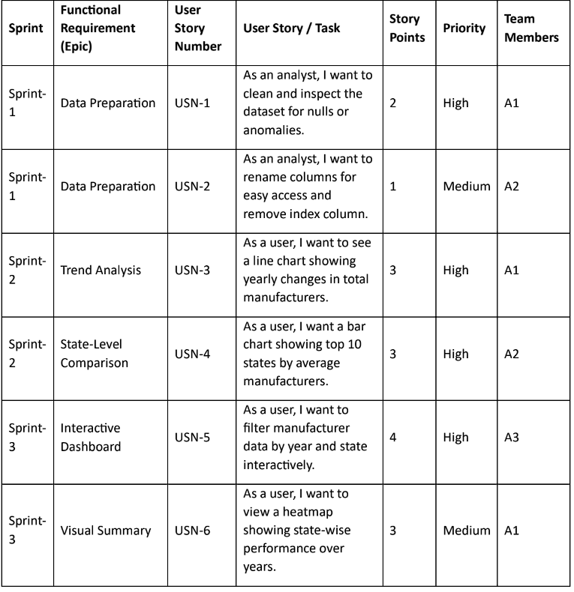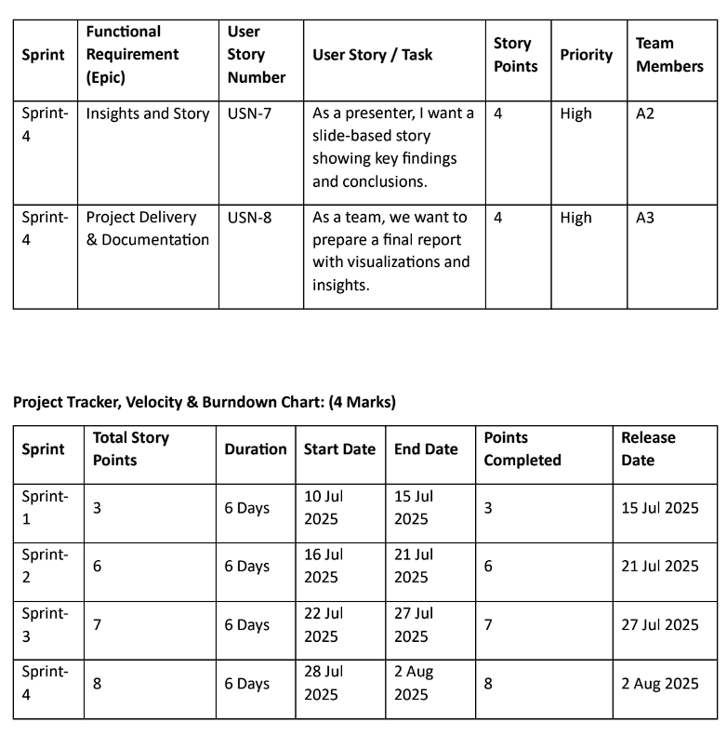
6. PERFORMANCE TESTING :
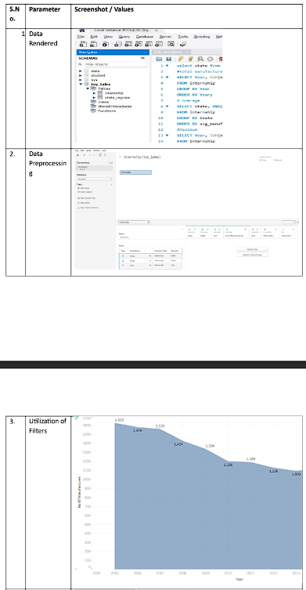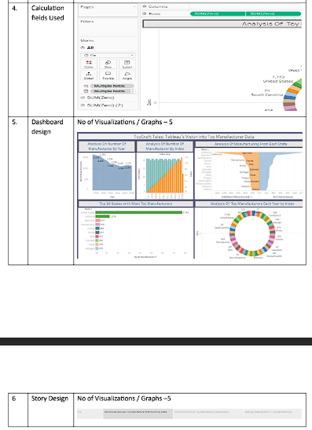
7. RESULTS :
7.1. Output Screenshots:

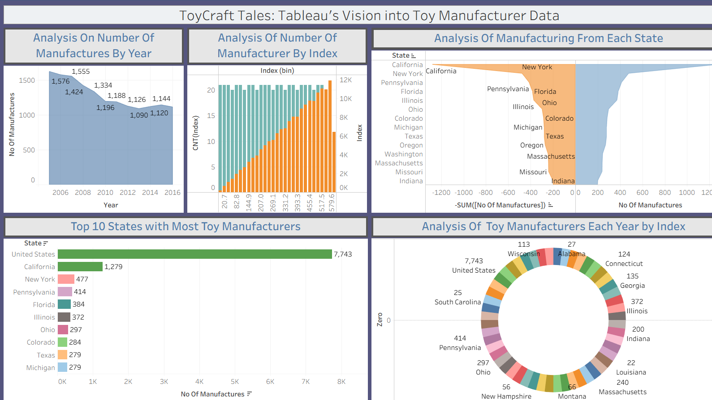8. ADVANTAGES & DISADVANTAGES
Advantages
Advantage | Description
1. Easy to Understand & Use | Tableau dashboards offer intuitive drag-and-drop interactivity, making them accessible even to non-technical users such as policymakers or analysts.
2. Actionable Visual Insights | Filters and visuals allow users to instantly identify national and state-level manufacturing trends across years.
3. Data-Driven Decision-Making | Replaces assumptions with clear, evidence-based insights derived from manufacturing data between 2005–2016.
4. Customization & Flexibility | Users can filter by year, state, or average thresholds to tailor insights to specific policy or business goals.
5. Visual Storytelling | Tableau Story enables structured, step-by-step presentation of findings — ideal for investor reports or government presentations.
6. Low Cost & Lightweight Setup | Uses freely available tools (Tableau Public and CSV files) without the need for expensive software or infrastructure.
7. Scalable Design | The dashboard can easily scale to include more states, additional years, or new manufacturing sectors.

Disadvantages
Disadvantage | Description
1. Static Data Source | The CSV file is not updated in real-time; any new data must be manually imported.
2. No Predictive Capabilities | The dashboard offers descriptive insights only — it doesn't forecast future manufacturing growth.
3. Limited Automation | Without connection to a live database or API, automated refresh and alerts are not possible.
4. Requires Tableau Familiarity for Editing | While easy to use, customizing visuals or adding new charts requires knowledge of Tableau Desktop.
5. No Backend Storage for Dashboard History | Tableau Public doesn't support historical version control unless hosted on Tableau Server or Tableau Cloud.

9. CONCLUSION
This project, "US Toy Manufacturing Analysis Using Tableau", effectively demonstrates how public industry data can be turned into strategic insights through visual analytics.
By transforming a static dataset (US Toy Manufacturers – 2005 to 2016.csv) into an interactive and filterable Tableau dashboard, the solution empowers stakeholders to:
- Track national and state-wise manufacturing trends
- Identify top and bottom-performing regions across time
- Recognize long-term patterns that are not visible in flat spreadsheets
- Present findings visually through maps, line charts, and highlight tables
This dashboard acts as a decision-support tool for:
- Policymakers looking to encourage industrial growth
- Economists analyzing regional production patterns
- Business analysts exploring market viability in different states
Through structured sprint planning and agile development, all major objectives were met:
- Improved visibility into U.S. toy manufacturing trends
- Reduction in reliance on manual reporting
- Enhanced stakeholder understanding through visual narratives
While the current system is limited by static data and lacks predictive capabilities, the foundation created is strong, extensible, and ready for next-level enhancements.
In summary: the project proves that Tableau is a powerful tool for turning manufacturing data into actionable insights, enabling data-backed decisions at both state and national levels.

10. FUTURE SCOPE
Future Enhancement | Details
1. Real-Time Data Integration | Use live connections from public APIs, online databases, or cloud sheets to auto-refresh manufacturer counts annually or quarterly.
2. Predictive Analytics & ML | Integrate Python/R models to forecast state-wise manufacturer growth and detect early signs of decline using seasonal or macroeconomic factors.
3. Cloud Deployment for Collaboration | Host on Tableau Cloud or Server for shared, role-based access by government, industry, and academic institutions.
4. Deeper Segmentation | Add segmentation by company size (small/medium/large), or by product type (educational toys, electronic, plastic, etc.).
5. Historical Comparison Features | Enable month-over-month or year-over-year toggle view with trendlines and annotations for long-term policy review.
6. Dashboard-as-a-Service Model | Offer this Tableau dashboard as a service (DaaS) to policymakers, toy associations, or manufacturing boards with customizable branding.

11. APPENDIX
Dataset Used:
Week 39 – US Toy Manufacturers – 2005 to 2016.csv (includes state, year, number of manufacturers)
Tools Used:
- Tableau Public/Desktop – For dashboard creation
- Google Sheets / Excel – For data inspection and backup
- Canva / PowerPoint – For presentation formatting
- Python + Pandas (optional) – For advanced data cleaning or preprocessing
Project Team:
D. Manoj Kumar
K. Gowtham
V. Siva Rama Krishna
Abhay Oraon
Institution:
Aditya College of Engineering & Technology
Department of Data Science (2023–2027)

• Dataset Link –
https://www.kaggle.com/datasets/thedevastator/toy-manufacturers-in-us-states?select=Week+39+-+US+Toy+Manufacturers+-+2005+to+2016.hyper
• GitHub – https://23p3a14411.github.io/US-TOY-MANUFACTURERS-/
• Project Demo Link -
https://drive.google.com/drive/folders/1o6EmX2DiDooxzPSUcLTiKfiMnjX1v5NV?lfhs=2

